# Chapter 6 Notes

## E6-1 Unpivot Columns and Unpivot Other Columns

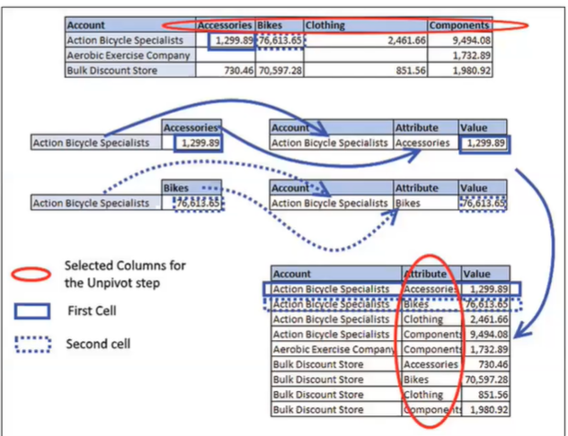

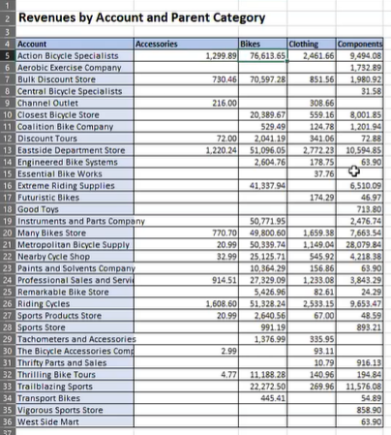

1. Open a New blank workbook then go to data > get data > from file> from workbook > E601
2. Click Revenues table not Sheet because it has nulls. Then click Transform Data
3. Options to choose from:
   1. Right click Account the select Unpivot Other Columns. This will grab Account as the anchor.
   2. Or: select all four columns Accessories, Bikes, Clothing, and Components and right click and click Unpivot Columns

## E6-2 Unpivoting Only Selected Columns

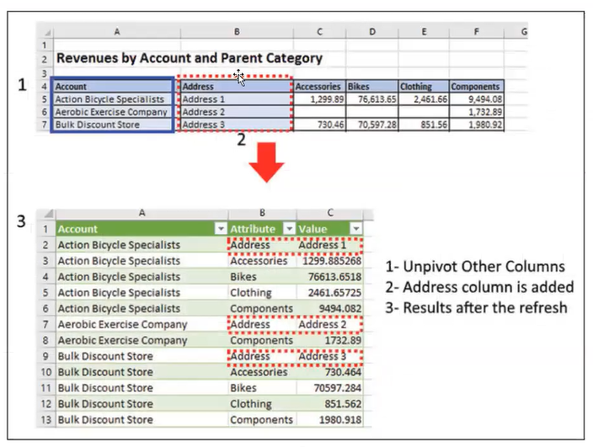

* If you hard code the column and you add a new column it is treated as a anchor column and then it will be applied to all of them.

1. Open a new Excel workbook
2. Data > get data > from workbook
3. Look to import C06E02
4. Click Revenues table then transform data
5. Select all the columns that contain the years 2015, 2016, 2017, and 2018
6. Then right click and select Unpivot Only Selected Columns
7. This will then add a different formula in the formula bar as compared to the previous exercise



## E6-3 Unpivoting Grand Totals (if there are also nulls in the values)

* What happens when you want to unpivot a table that has a grand total

1. Data > get data > from workbook > C06E03
2. Select the Revenues table then transform data

* You will see a grand total at the bottom and far right column

1. Right click the far left column containing Account then select Unpivot Other Columns

* You will see a grand total for each item
* You can filter out those grand total rows which is ok
* However we will try something else but first continue following the steps you do not have to make any changes yet.

1. Click Close and Load To
2. Only Create Connection and also Add this data to the Data Model
3. Go to Data > Manage Data Model
4. Then click Pivot Table
5. Then Click Existing Worksheet
6. Move Account to Rows
7. Move Attribute to Columns
8. Move Value to Values

---

1. Open up the Revenue Query
2. Remove the Unpivoted Other Columns from the Revenues Query
3. Remove the last column Grand Total
4. Home > Remove Rows > Remove Bottom Row
5. Number of rows just type 1
6. Right click the Account column and select Unpivot Other Columns
7. Close and Load to
8. Now you will see the numbers are correct.

In the Power Query Editor it should look like this: (renamed the titles from Attribute: Parent Category, Value: Revenue

* Just remove the grand total from last column and last row to make it look like this.
* Unpivot other column when selecting Account

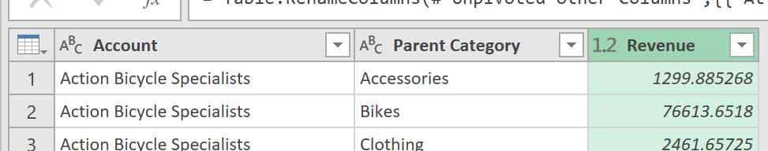

## E6-4 Unpivoting 2x2 Hierarchies with Dates

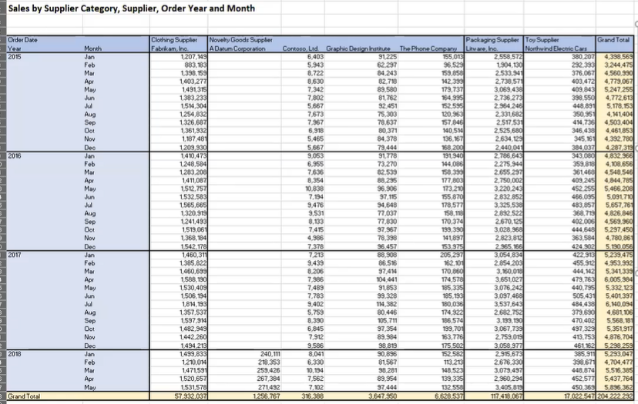

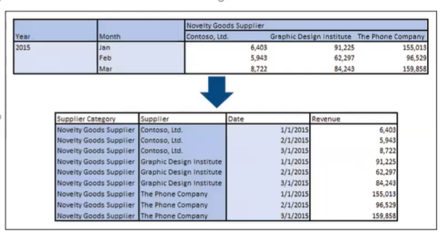

1. Data> get Data > from File > from Workbook
2. Select C06E04
3. Select Revenues then select transform data

* You will see some columns have names already and some do not

1. From the Applied Step remove the Changed Type and Promoted Headers
2. Home> remove Rows > Remove Bottom Rows

* Enter in 1
* This will remove the Grand Total row and column

1. Select the First column > Transform Tab > Fill > Down
2. Select Column 1 and Column 2
3. Transform > Merge Columns > make the separator as a Space and rename the column Order Date
4. Transform > Transpose
5. Select Column1 then go to Transform > Fill > Down this will replace the nulls
6. Now click Transform > Use First Row as Headers
7. Select the two columns which will be your anchor columns: Order Date and Year Month
8. Right click then select Unpivot Other Columns
9. Rename the Columns now

* Rename Order Date to Supplier Category
* Rename Year Month to Supplier
* Rename Attribute to Date
* Rename Value to Revenue

1. Select the date columns then go to Home > Data Type: Date
2. Now Done

## E6-5 Unpivoting 2x2 Hierarchies

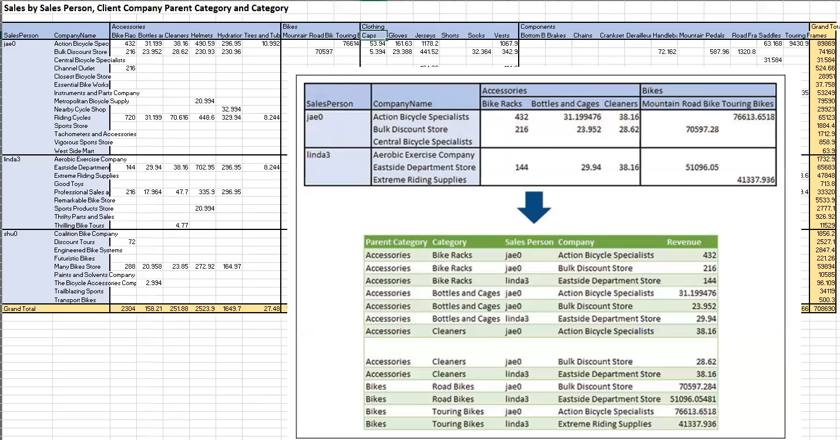

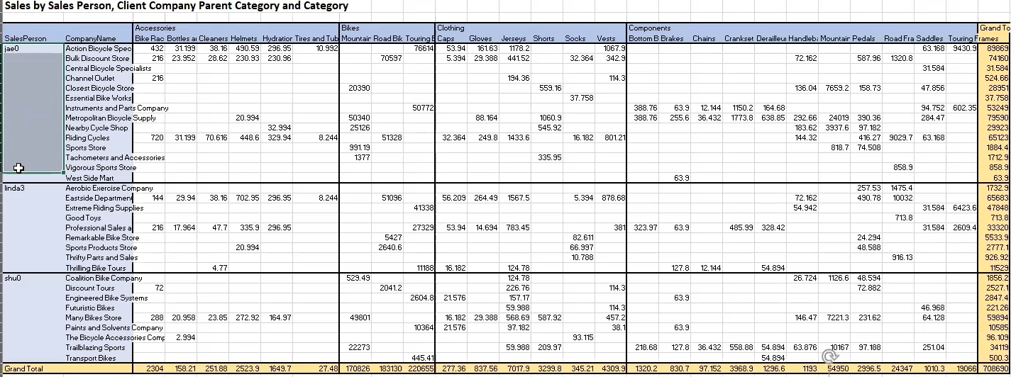

* What do you do when you have a table with so many empty cells. It looks ok when using it but PowerQuery cannot show it properly

1. Open a new excel file then go to Data > get data > From File > From Workbook > C06C05
2. Select the Revenue then transform data
3. Remove the Change Type and Promoted Headers from Applied Steps
4. Home > Remove Rows > Remove Bottom Rows

* Add in the number 1

1. Remove the very far right column which contains Grand Total
2. Select the first column above a null then click Transform > Fill > Down
3. Select Column 1 and 2 the right click Merge Columns

* Separator Colon
* Rename the column to Merged

1. While selecting the first column, Go to Transform > Transpose
2. Select the first Item in the First Row then go to Transform > Fill > Down
3. Transform > Use First Row as Headers
4. Select the First Two Columns these will be the anchors
5. Right click and select Unpivot Other Columns

* Now we just need to split the attribute column into their own values

1. transform > Split Column > By Delimiter

* Select or enter delimiter: Colon
* Split at: Each occurrence of the delimiter

1. Rename the Columns now

* Replace : with Parent Category
* SalesPerson.. to Category
* Attirbute.1 to Sales Person
* Attribute.2 to Company
* Value to Revenue

## E6-6 Dealing with Subtotals

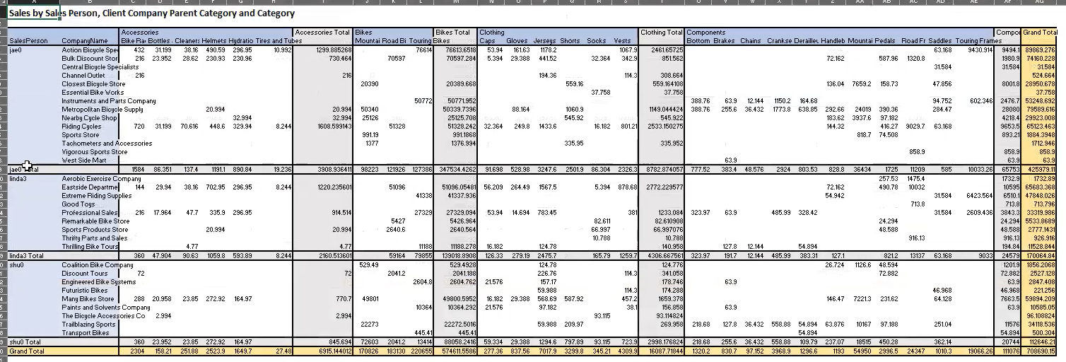

* The grey area has subtotals
* Remove subtotals only when you are done the pivoting

1. Data > Get Data > From File > From Workbook > C05E06
2. Select the Revenues then Transform Data
3. Remove Changes Type and Promoted Headers
4. Select the Grand Total on the Last Row then > remove Rows > Remove Bottom Rows

* Select 1

1. Remove the last column containing Grand Total
2. Select First Row then transform > Fill > Down
3. Merge the First two Columns for Column 1 and Column 2

* Separator: Colon
* Title: Merged

1. transform > Transpose
2. First column just select Transform > Fill > Down
3. Transform > Use First Row as Headers
4. Select the First Column and Second Column then right click and Unpivot Other Columns
5. Select the Attribute Column > Right Click > Split Column > By Delimiter

* Select or enter delimiter: Colon
* Split at : Each occurrence of the delimiter

1. Rename Columns

* Parent Category
* Product Category
* Sales Person
* Company Name
* Value



1. Remove Filtered Rows in Applied Steps if its there
2. Select the parent category drop down then go to Text Filters > Does Not End With…

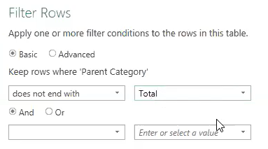

1. Select the Sales Person Dropdown then Text Filters > Does Not End With…

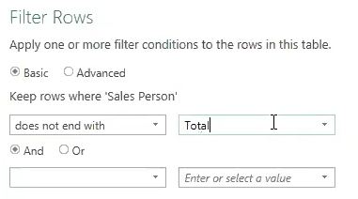

Done